Bitcoins & its impact on global money
J.D Jayaraman,
Ph.D. Associate Professor & Co-Chair
Department of Finance & Data Science
New Jersey City University

Sameh Hezkial
Con-Edison

Abstract
Money allows us to meet our basic needs—to buy food and shelter and pay for healthcare. Meeting these needs is essential, and if we do not have enough money to do so, our personal wellbeing and the wellbeing of the community suffer greatly. Money, whether it is represented by a seashell, a metal coin, a piece of paper, or a string of code electronically mined by computer, does not always have value. Its total global value—currently estimated to be around $418 trillion—depends on the importance that people place on it as a medium of exchange, a unit of measurement, and a storehouse for wealth. Nowadays, as we are living in the fifth tehasal revolution (Age of information and telecommunications) money is having a different form & playing a different role in our lives which must be known by all.

Table of contents
- The importance of the Money.
- The Role of Money.
- The origin of the Money.
- The value of Digital Currencies.
- How Bitcoin Transforms Global Economy.
- Disadvantages of Bitcoin.
- Impact of Bitcoin as a World Currency (especially on the U.S dollar which is our focus in this case study).
Why Money is important & the role it plays in our lives.
The reason money is so important is that it provides options for you to live a better life than you choose and puts you in control. Having money and being comfortable with finances also gives you freedom and options to decide how you want to live and support the things you care most about in your life. Money is not everything in this world, but it can be powerful in giving you freedom or more options for your life, creating financial security, helping you achieve your goals and letting you make the best of the short life we all have.
What is the key role of money?
Money has taken many forms through the ages, but money consistently has three functions: store of value, unit of account, and medium of exchange.
- Store of value: asset that would normally retain purchasing power into the future and is the function of the asset that can be saved, retrieved, and exchanged later, and be predictably useful when retrieved.

- Unit of account: a standard numerical unit of measurement of the market value of goods, services, and other transactions.

- Medium of exchange: it facilitates transactions of goods and services; Producers sell their goods to wholesalers in exchange of money. Wholesalers, in turn, sell their goods to the retailers and the retailers sell these goods to the consumers in exchange for money.

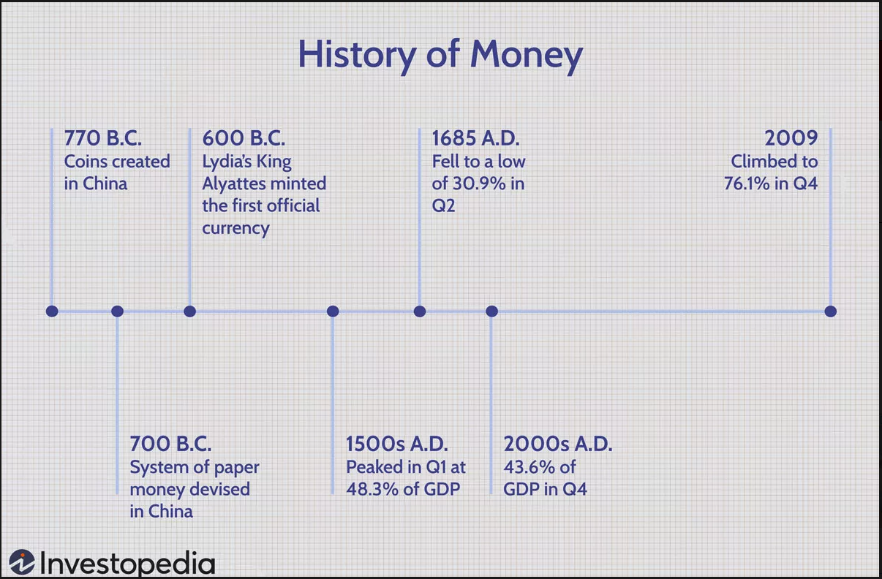
The History of Money

The Transition from Bartering to Currency
Money—in some form or another—has been part of human history for at least the past 5,000 years.
Before that time, historians agreed that a system of bearing was used.
Bartering is a direct trade of goods and services; for example, a farmer may exchange a bushel of wheat for a pair of shoes from a shoemaker. However, these arrangements take time. If you are exchanging an ax as part of an agreement in which the other party is supposed to kill a woolly mammoth, you must find someone who thinks an ax is a fair trade for having to face down the 12-foot tusks of a mammoth. If this does not work, you will have to alter the deal until someone agrees to the terms.
Slowly, a type of currency developed over the centuries that involved easily traded items like animal skins, salt, and weapons. These traded goods served as the medium of exchange (even though the value of each of these items was still negotiable in many cases). This system of trading spread across the world and still survives today in some parts of the globe.
One of the greatest achievements of the introduction of money was the increased speed at which business, whether it involved mammoth-slaying or monument-building, could be done.
In early August 2021, Chinese archaeologists with the State University of Zhengzhou announced that they had discovered the world’s oldest known, securely dated coin minting site. A mint is a facility where currency is created. Sometime around 640 BCE, this facility, located in Guan Zhuang in Henan Province, China, began striking spade coins, one of the first standardized forms of metal coinage.
First Official Currency Is Minted
Meanwhile, further west during this era, the sixth-century BCE Greek poet Xenophanes, quoted by the historian Herodotus, ascribed the invention of metal coinage to the Lydians. In 600 BCE, Lydia's King Alyattes minted what is believed to be the first official currency, the Lydian stater.
The coins were made from electrum, a mixture of silver and gold that occurs naturally, and the coins were stamped with pictures that functioned as denominations. In the streets of Sardis, at approximately 600 BCE, a clay jar might cost you two owls and a snake.
Lydia's currency helped the country increase both its internal and external trading systems, making it one of the richest empires in Asia Minor. Today, when someone says, "as rich as Croesus", they are referring to the last Lydian king who minted the first gold coin.
Transition to Paper Currency
During 1260 CE, the Yuan dynasty of China moved from coins to paper money.
By the time Marco Polo—the Venetian merchant, explorer, and writer who traveled through Asia along the Silk Road between 1271 and 1295 CE—visited China in approximately 1271 CE, the emperor of China had a good handle on both the money supply and its various denominations.
In fact, in the place where modern American bills say, "In God We Trust," the Chinese inscription at that time warned: "Those who are counterfeiting will be beheaded."
Parts of Europe were still using metal coins as their sole form of currency until the 16th century. Colonial acquisitions of new territories via European conquest provided new sources of precious metals and enabled European nations to keep minting a greater quantity of coins.
However, banks eventually started using paper banknotes for depositors and borrowers to carry around in place of metal coins. These notes could be taken to the bank at any time and exchanged for their face value in metal—usually silver or gold—coins. This paper money could be used to buy goods and services. In this way, it operated much like currency does today in the modern world. However, it was issued by banks and private institutions, not the government, which is now responsible for issuing currency in most countries.
The first paper currency issued by European governments was issued by their colonial governments in North America. Because shipments between Europe and the North American colonies took a long time, colonies often ran out of cash. Instead of going back to a barter system, the colonial governments issued IOUs that traded as currency. The first instance was in Canada (then a French colony). In 1685, soldiers were issued playing cards denominated and signed by the governor to use as cash instead of coins from France.
The Emergence of Currency Wars
The shift to paper money in Europe increased the amount of international trade that could occur. Banks and the ruling classes started buying currencies from other nations and created the first currency market. The stability of a particular monarchy or government affected the value of the country's currency, and thus, that country's ability to trade on an increasingly international market.
The competition between countries often led to currency wars, where competing countries would try to change the value of the competitor's currency by driving it up and making the enemy's goods too expensive, by driving it down and reducing the enemy's buying power (and ability to pay for a war), or by eliminating the currency completely.
Payment Cards
Payment cards are part of a payment system issued by financial institutions, such as a bank, to a customer that enables its owner (the cardholder) to access the funds in the customer's designated bank accounts, or through a credit account and make payments by electronic transfer (using chip & PIN or contactless) and access automated teller machines.
Mobile Payments
The 21st century has given rise to two novel forms of currency: mobile payments and virtual currency. Mobile payments are money rendered for a product or service through a portable electronic device, such as a cellphone, smartphone, or tablet device.
Mobile payment technology can also be used to send money to friends or family members. Increasingly, services like Apple Pay and Google Pay are vying for retailers to accept their platforms for point-of-sale payments.
Virtual Currency
Bitcoin​, released in 2009 by the pseudonymous Satoshi Nakamoto, quickly became the standard for virtual currencies.
All the world's bitcoin, as of June 2022, were worth just over $392 billion.
Virtual currencies have no physical coinage. The appeal of virtual currency is that it offers the promise of lower transaction fees than traditional online payment mechanisms do and is operated by decentralized authorities, unlike government-issued currencies.
The Value of Digital Currencies
Any discussion about the value of Bitcoin must address the nature of currency. Gold was useful as currency due to its inherent physical attributes, but it was also cumbersome. Paper money was an improvement, but it requires manufacturing and storage and lacks the mobility of digital currencies. The digital evolution of money has moved away from physical attributes, and towards more functional characteristics.
Here is an example. During the fiscal crisis, Ben Bernanke, who was then the governor of the Federal Reserve, appeared on CBS' 60 Minutes and explained how the agency "rescued" insurance giant American International Group (AIG) and other financial institutions from bankruptcy by lending money to them. Puzzled, the interviewer asked whether the Fed had manufactured billions of dollars. That was not the case.
"So, to lend to a bank, we simply use the computer to mark up the size of the account that they have with the Fed," explained Bernanke. In other words, the Fed "manufactured" U.S. dollars through entries in its ledger.
This ability to "markup" an account exemplifies the nature of currencies in their digital form. It has implications for the velocity and use of currencies because it simplifies and streamlines transactions involving them.
Why Does Bitcoin Have Value?
Bitcoin does not have the backing of government authorities, nor does it have a system of intermediary banks to propagate its use. A decentralized network consisting of independent nodes is responsible for approving consensus-based transactions in the Bitcoin network. There is no fiat authority in the form of a government or other monetary authority to function as a counterparty to risk and make lenders whole, so to speak, if a transaction goes awry.
Cryptocurrency does display some attributes of a fiat currency system, however. It is scarce, and it cannot be counterfeited. The only way that one would be able to create a counterfeit bitcoin would be by executing what is known as a double-spend. This refers to a situation in which a user "spends" or transfers the same bitcoin in two or more separate settings, effectively creating a duplicate record.

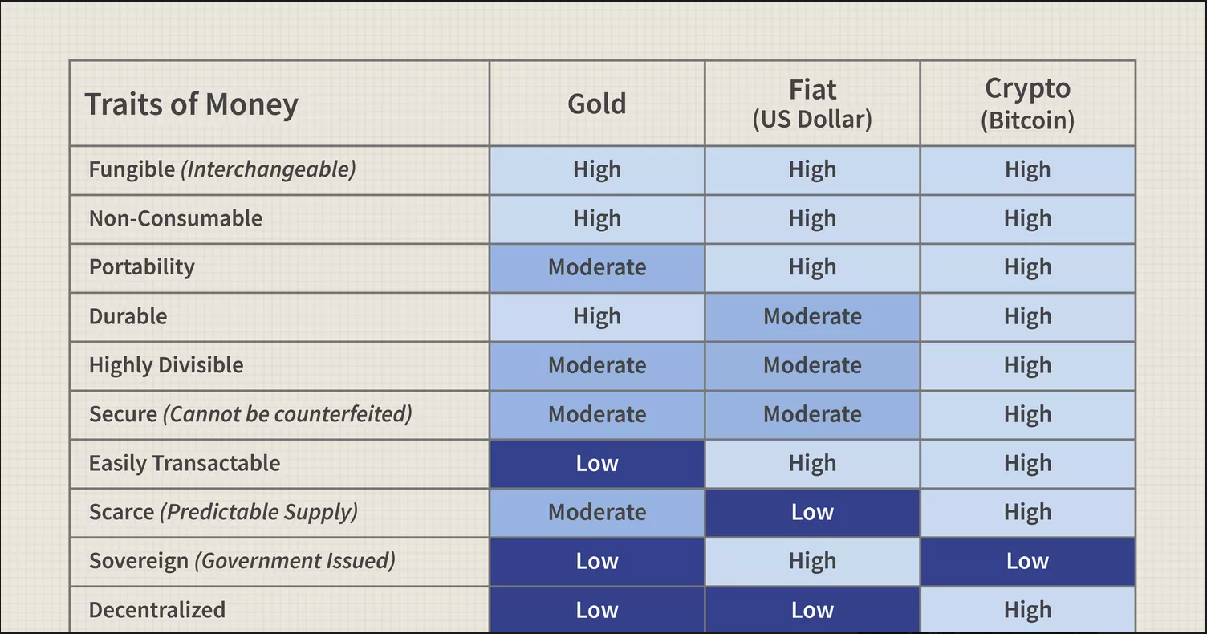

Utility
What makes double-spending unlikely, though, is the size of the Bitcoin network. A so-called 51% attack, in which a group of miners theoretically controls more than half of all network power, would be necessary. By controlling most of all network power, this group could dominate the remainder of the network to falsify records. However, such an attack on Bitcoin would require an overwhelming amount of effort, money, and computing power, thereby rendering the possibility extremely unlikely.
But Bitcoin often fails the utility test because people rarely use it for retail transactions. The main source of value for Bitcoin is its scarcity. The argument for Bitcoin's value is like that of gold commodity that shares characteristics with cryptocurrency. The cryptocurrency is limited to a quantity of twenty-one million.
Bitcoin is much more divisible than fiat currencies. One bitcoin can be divided into up to eight decimal places, with constituent units called Satoshi. Most fiat currencies can only be divided into two decimal places for everyday use.
If Bitcoin's price continues to rise over time, users with a tiny fraction of bitcoin will still be able to make transactions with cryptocurrency. The development of side channels, such as the Lightning Network, may further boost the value of Bitcoin's economy.
Scarcity
Bitcoin's value is a function of this scarcity. As the supply diminishes, demand for cryptocurrency has increased. Investors are clamoring for a slice of the ever-increasing profit pie that results from trading its limited supply.
Bitcoin also has limited utility like gold, the applications for which are industrial. Bitcoin's underlying technology, called blockchain, is evaluated and used as a payment system. One of its most effective use cases is in remittances across borders to bump up speed and drive down costs. Some countries, like El Salvador, are betting that Bitcoin's technology will evolve sufficiently to become a medium for daily transactions.
Marginal Cost of Production
Another theory is that Bitcoin does have intrinsic value based on the marginal cost of producing one bitcoin.
Mining for bitcoins involves a great deal of electricity, and this imposes an actual cost on miners. According to economic theory, in a competitive market among producers all making the same product, the selling price of that product will tend towards its marginal cost of production. Empirical evidence has shown that the price of a bitcoin tends to follow the cost of production.
Monetarist Theories
Monetarists try to value bitcoin as they would money, using the supply of money, its speed, and the value of goods produced in an economy. The simplest way to this approach would be to look at the current worldwide value of all mediums of exchange and of all stores of value comparable to Bitcoin and then calculate the value of Bitcoin's projected percentage. The predominant medium of exchange is government-backed money, and for our model, we will focus solely on that. Roughly speaking, the money supply (M1) in the U.S. was worth more than $20 trillion as of the end of 2021.
Assuming this total remains stable, if Bitcoin were to achieve 15% of this valuation, its market capitalization in today's money would be approximately $3 trillion. With all twenty-one million bitcoins in circulation, which would put the price of one bitcoin at $143,000.
The Challenges of Valuing Bitcoin
One of the biggest issues is Bitcoin's status as a store of value. Bitcoin's utility as a store of value depends on how well it works as a medium of exchange. If Bitcoin does not achieve success as a medium of exchange, it will not be useful as a store of value.
Throughout much of its history, speculative interest has been the primary driver of Bitcoin's value. Bitcoin has exhibited the characteristics of a bubble with drastic price run-ups and a craze of media attention. This is likely to decline as Bitcoin continues to see greater mainstream adoption, but the future is uncertain.
Difficulties surrounding cryptocurrency storage and exchange spaces also challenge Bitcoin's utility and transferability. In recent years, hacks, thefts, and fraud have plagued digital currency.
How Bitcoin Transforms Global Economy
- Here are some visible impacts of Bitcoin on the worldwide economy:

- Shifts in global investments.
Many investors are now adding cryptocurrencies, particularly Bitcoin, into their portfolios. This is most likely because bitcoin allocation higher their chances to improve portfolio upside.

- A hedge against inflation.
Bitcoin advocates regularly point out that Bitcoin is not affected by inflation. They draw attention to the fact that there is a limited amount of Bitcoin, a situation they compare to the regular money circuit, where in principle central banks can introduce an infinite amount of money to the market.

- Separates Transactions from the Dollar.
Cryptocurrencies do not require any connection to the U.S. dollar. The involved parties of a financial transaction are given another avenue to participate in the global economy while, at the same time, circumventing U.S. economic policies.

Even though it might seem like a threat to the government because the U.S. dollars function as the reserve currency for the global economy (which is the primary source of US’ global power), it enables more international transactions.

- Eliminates the Need for Middlemen.
Bitcoin is inherently designed to allow peer-to-peer electronic transactions between counterparties without the intervention of any third party. It does not require an intermediary, or a go-between, unlike the traditional currency. Transactions are validated in a decentralized fashion.

This fact has made banking institutions anxious, as it eliminates the need for their service. What is more, transacting through cryptocurrencies is much quicker as it does not have to pass through multiple hands.

- Encourages More Overseas Transactions.
Since lots of people living in countries around the world with weak economies still do not have a bank account, Bitcoin comes in handy to engage them with the global internet economy.

That way, people who live in typically less developed countries have a chance to connect with the internet economy. All that is needed is a digital wallet to make transactions anywhere in the world.

The transaction is quite fast, transparent, confidential, and secure. Also, the transaction fees may be much more affordable than in conventional payment systems (credit or debit cards).

- Reduces High Reliance on Fiat Money.
As a decentralized currency, Bitcoin is free from any economic and political issues that can often affect traditional currencies. That is where Bitcoin is designed to be a digital currency that can be an alternative for authorized or fiat money.

Today, customers have become more reliant on digital transfer (as it is convenient in the sense of transaction speed) as a handy means to pay for products and services. Using Bitcoin as a payment method can reduce the reliance on traditional or authorized money.

- Regulation of Bitcoin.
Now that Bitcoin has become ubiquitous, both national and regional authorities are prompt to grapple with their financial regulations. In this matter, central banks are working hard to put this ad hoc financial system under control. It can lead to laws specifically addressing this cryptocurrency and speculative bubble that Bitcoin will potentially cause.

Different countries have different approaches to cryptocurrency, some of them (Algeria, Bolivia, Morocco, Nepal, Pakistan, and Vietnam) ban any or all activities involving Bitcoin.

In contrast, some others use it as a means of payment. For example, in the U.S.A, Canada, Australia, the European Union accepts cryptocurrencies, including Bitcoin, as a means of payment even by government agencies.

- Removes Barriers to Entry and Emerges New Market.
Bitcoin established a global decentralized transaction network that eliminates the necessity of any centralized institutions for currency issuance and settlement. In this case, it has opened the door for a new kind of market and opportunities where no authority or individual controls the money market.

So, rather than persuading the venture capitalists, banks, and other financial institutions for their prospective project, they can bypass the regulations and authority through Initial Coin Offerings (ICO). With ICO, startups and small businesses around the world can sell some of their coins to get their business off the ground.

- Opens Access to a Credit System.
Bitcoin enables unbridled access to a reliable credit system since it is a type of unregulated digital currency that is based on data. If the price remains stable for an extended period, it will be able to bridge people who are isolated from global merchants continuously.

Thus, it will open new markets as well as new opportunities that can contribute to sustainable and inclusive growth in the global economy. What is more interesting is that Bitcoin does not require any pricey fees for transactions, which makes it much more appealing for its users– and people who are considering using it.

10 -Starts New Era of Crowdfunding.
Talking about Bitcoin and cryptocurrencies is not complete without mentioning ICOs. In 2017, it was the talk of the technology town as it has become the leading crowdfunding method for blockchain-based startups. This new method of crowdfunding allows companies or organizations to raise capital in the form of cryptocurrencies.

What happens in ICO crowdfunding is that the investors buy cryptocurrency coins that represent shares in the project, just like how the stock market works. Hence, the shares have the potential to increase in value if the company does well. It is referred to as crypto equity crowdfunding.

This new era of crowdfunding is crucial in helping inventors, entrepreneurs, and creators improve the world, including creating a sustainable economy.

11- Changes in the International Remittances Industry.
Overseas remittance drives economic growth in emerging economies. That way, many people around the world work overseas and regularly send money to their families and loved ones in their home country.

At present, this money must be managed by intermediaries, including banks or other money transfer services that charge prohibitive costs for transaction fees. Also, the transaction process is so slow and takes several days before the receiving party can access the funds. In this matter, Bitcoin comes as a gamechanger.
Bitcoin can instantly be transferred across the globe securely. It makes the overseas remittance process a lot easier, cheaper, and more secure. Today, at least 11 Bitcoin providers have already started foreign remittance services, including Ribbit, BitPesa, and Abra.

12- Environmentalism.
Every coin has two sides, so does Bitcoin. Other than the direct and straightforward impact that Bitcoin gives to the global economy, it also impacts the environment– in a not-too-subtle way.

Bitcoin mining requires a sophisticated software and hardware infrastructure system, and it accounts for a more significant deal of energy than the entire world uses today.

It takes at least a staggering 77 TWh (Terawatt-hour) each year to operate the computers and networks that power Bitcoin operations.

With more people dabbling in the Bitcoin network and trying to mine it, this insane amount of energy will still have the potential to increase.

In such cases, environmental law and regulatory framework will have to be created to address energy consumption related to bitcoin mining.

Disadvantages of Bitcoin
- It cannot be a global reserve currency.
Despite the enormous potential that Bitcoin has for the global economy, Bitcoin cannot easily be a replacement for authorized money and be used as the base currency for the whole economy.

- Bitcoin became a financial asset or an investment which increased its risk as its value fluctuates a lot during time so sometimes it becomes unsecure Payment method ex: Taxes & Loans.

- The absence of a central regulator.
The blockchain is good for privacy, as explained above, but it also means that if anything goes wrong, no central authority can be called upon to fix it. Human error is responsible for all payment transactions that have gone wrong. People occasionally mistakenly transfer money to the wrong account. They can be tricked into transferring money to a fake account (spoofing). A third example: people sometimes pay the incorrect amount. In many if not most cases like these, banks can resolve payment errors. Even when, through no fault of the account holder, an outside party hacks an account, banks often (partly) compensate the account holder’s damage. Not so in the blockchain. If a payment goes wrong or a wallet is hacked and emptied, users cannot do anything to fix it.

- What to Do If You Forget Your Wallet Password.
Given the current price spike, losing your Bitcoin wallet password is remarkably similar to losing a winning lottery ticket. The solution? Cry your eyes out and try again. Some (difficult to verify) accounts maintain that 20 percent of all wallets can no longer be accessed by their owners. The contents of these wallets can be huge sums, especially those belonging to people who bought a few hundred dollars in Bitcoin for just a few cents per Bitcoin. The internet has stories to tell about lost passwords, people who deleted passwords while reformatting their hard drives, and people who discarded old computers only to realize their wallet had ended up on the garbage belt with it. The lesson is simple: pay better attention. Because there is no central regulator protecting Bitcoin users.

But, of course, you could also argue that the people who choose to hold (part of) their assets in Bitcoin are aware of this. It is the risk you inevitably run in exchange for far-reaching privacy and the absence of central supervision. Whether every enthusiastic Bitcoin follower who has recently jumped in realizes this is an open question.

Impact of Bitcoin as a World Currency (especially on the U.S dollar which is our focus in this case study).
In an era of technology advancement when the entire world is talking about the “Internet of Things” whereby we are expected to have connectivity between anything and everything, Currency cannot be left behind. Paper currency is bound to be outdated, as virtual currencies will start taking over and Bitcoin is well poised to achieve this feat. Not only it will revolutionize the way payments are made but also have potential to impact the future of world currencies like USD, which is already facing challenges from EURO or Chinese Yuan Renminbi (CNY). The rise of crypto currencies will add a new dimension to this challenge for US Dollar (USD) The focus of this study is to understand multiple factors which are translating Bitcoin (BTC) that is gaining momentum in various fields of global finance and how disruptive it can be, including replacing main fiat currencies in the financial system impacting mainly USD. The key variables studied are Regulation or lack of it around Bitcoin, Bitcoin Technology, Bitcoin Economy, and the usage of Bitcoin as a Currency.

USD as a world currency has survived for decades, though Japanese Yen did become increasingly popular as an international currency during the 1980s. Of late, both Chinese Renminbi and EURO are challenging the USD in the International Finance. It is also evident that the share of USD in the reserve currency is falling, though.
Overall, the Reserve Currency is increasing globally. However, neither Yuan nor EURO can compete strongly with USD due to its valuation’s problems, i.e., Chinese Yuan is considered as undervalued whereas EURO being as Overvalued.

Although the Renminbi may indeed present a viable alternative at some point, for the near future the dollar.
will remain preeminent. The closest rival was the EURO, but since the crisis began in the region, EURO currency reserve accumulation has been decreasing. Similarly, Yuan lacks the primary prerequisite to
becoming a global currency, i.e., free, and full convertibility. If CNY wants to dominate, it will have to establish itself as a Regional Currency, which can be the first step towards internationalization.

Another view about CNY is, it seems inevitable that by 2024 the RMB will indeed be playing a key role in global payments and banking and will have replaced the Japanese yen as the principal Asian currency. No currency is free of challenges in the global economic environment including USD. However, the US dollar will remain the world's reserve currency of choice if there is no credible alternative. Reserve currency countries enjoy exorbitant benefits like cheap borrowings. It cannot last longer as this resents other economies and therefore over a period emerging economies either want to get themselves added to the list of dominant world currencies or will start demanding an alternate currency altogether. The view supported by the announcement (Nov 2015) by the International Monetary Fund to include China's Yuan, or Renminbi, as it is also known, in an exclusive group of currencies that make up the basket of the IMFs. Special Drawing Rights (SDR) is seen as a positive development for CNY. Inclusion represents USD’s weakening in its global position and acknowledgment of Chinese Renminbi’ strength in the global economy.

Researchers had mentioned in a discussion that in the 21st century, more comprehensive financial market integration and a single global currency could emerge. There are discussions on the formation of a global currency area (GCA), which would signal the natural end of the reserve currency system. Then, only one money unit would rule globally without any exchange rate and with technological advancement, a new dimension added to the discussion where Paper money belongs to the past. The future will be free from coins and paper money.

Amidst the above discussions, the rise of Bitcoin and similar cryptocurrencies may pose a serious threat to USD as this is as an alternative to existing World currencies including USD, due to its features. Bitcoin, the first cryptocurrency, was invented by Satoshi Nakamoto and introduced as open-source software in 2009 as a peer-to-peer system where users can transact directly without needing an intermediary. Bitcoin is often described as the first decentralized digital currency (Satoshi Nakamoto, 2008). Bitcoin currently has a market capitalization of around USD 5.9 Billion and continues to grow, subject to exchange rate stability, as more Bitcoins are mined every day.

Bitcoin started to make its presence felt in global finance during late 2013 and early 2014. The “pseudo currency” which was launched a few years earlier by computer hobbyists, and in late 2013 the USD exchange rate for one Bitcoin (BTC) rose more than five times in the short span of a few weeks. When it began trading in 2010, its market value was less than five cents per US Dollar, which had exceeded USD 1,200.00 during 2013.

For most of the last two centuries, the world’s powerful currencies were convertible into fixed amounts of gold or other precious metals, and for thousands of years before that, many currencies were minted directly from gold or silver species. The gold standard collapsed in most economies between the 1920s and 1970s, partly due to the pressures of financing two World Wars, but even more because worldwide production of gold did not keep pace with economic growth. Since then, every major economy has issued paper currency, the value of which relies on nation’s government or central bank will not increase the supply of new banknotes too rapidly. Multinational associations have issued currencies like the EURO on related terms. Fiat currencies have been in circulation for numerous years, and eventually all of them have been inflated down to triviality by governments faced by constrained public finances.

Bitcoin is an option which can overcome the challenges of both gold standards as well as fiat currencies. A virtual currency, which has a limited supply and that is too tied to mathematical programming, which can be adjusted i.e., Increased, or decreased to maintain the rate of supply. It is done without any intervention from the government or any intermediate agency. Instead, it provides for the rate of seigniorage to slow asymptotically to zero by the year 2140, when the last Bitcoin will be released, and the final total will be fixed at twenty-one million units. It is well known to the public at large, the quantities as well as the growth rates of Bitcoins with certainty, so its circulation cannot be affected by monetary policies.

The variables considered for this research study. The dependent variable is the
Impact of Bitcoin on USD, a world currency. Four independent variables have been identified i.e. (1) Regulation around Bitcoin globally or lack of it (2) Technology, which ensures security and privacy of the financial transactions and at the same time is very cost effective (3) Economy, which is ever increasing for Bitcoin; and (4) Bitcoin as a
Currency.

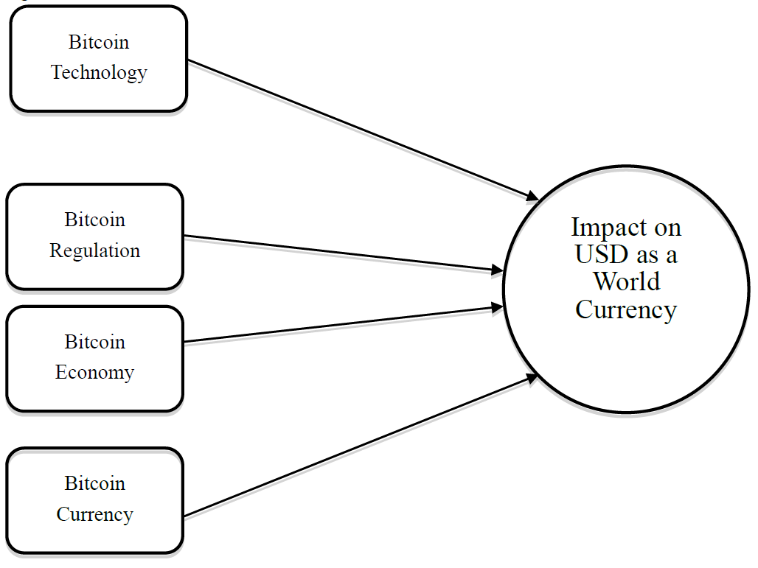

- Bitcoin Regulation:
As far as the regulation on Bitcoin is concerned, there is no consistency in the way various countries deal with Bitcoin. There is no consistency in guidance on the legal, accounting, tax, and audit-related standards. Thus, Regulation has become one of the most debated issues facing the digital currency industry. Bitcoin technology has many unique and unprecedented features that give it the potential to be disruptive and impact a broad range of industries and institutions. The ability to send money anywhere in the world in minutes, its peer-to-peer decentralized nature of value transfer and its completely digital existence, makes effective regulation of digital currencies so challenging for governments and policymakers have no clear legislation on digital currencies, which makes the process even more complex.

Government bodies, Central Banks, and Regulators have started to publish opinions on Bitcoin. These publications discuss the risks of Bitcoin (e.g., to customers or financial stability), potential regulatory responses or the legal and fiscal classification of Bitcoin.

In Europe, both the European Central Bank and the European Banking Authority discuss the risks of Bitcoin and potential regulatory stand. The ECB is focused on aspects relevant from a central bank’s perspective, i.e., risk to price stability, financial stability, the payment system, and reputational risks for central banks. In summary, the ECB
It concludes that virtual currency schemes do not pose significant risks, because of their low volume and limited interrelation with the real economy. Nonetheless, this could change if cryptocurrency schemes became more important and their use more extensive. The ECB further states that, as payment systems, virtual currency schemes
fall under the purview of central banks and therefore they also need to consider probable Reputational Risks as central banks may be held responsible by the public for incidents involving Bitcoins.

Several institutions globally have warned consumers against using or investing in Bitcoins, stressing the risks involved. The warning by the EBA (2013), insists that regulation does not protect users of Bitcoin and that the value of Bitcoins may not remain stable. The EBA (2013) discusses potential losses due to fraud, for example, hacking digital wallets and advises consumers to take care of potential tax liabilities resulting from the use of virtual currencies. In Austria, the warnings of the EBA reiterated by the FMA (2014). Similar warnings issued by the Banca d’Italia (2014) and the Banque de France (2013).

The views of the major regulators like World Bank, International Monetary Fund or even Federal Reserve that can influence the world on the position of Bitcoin are not consistent.

In the World Bank’s view, the abstract nature of Bitcoin poses a challenge to regulators. Like any form of monetary value, including cash, e-money, and credit cards, Bitcoin can be used for both legitimate and illicit purposes. The question is whether Bitcoin makes it easier for criminals to funnel money for illicit purposes, and how regulators.
should respond to these perceived or real risks.

In general, Regulatory bodies view Bitcoin in a negative light, for example, World Bank’s Research paper compared Bitcoin to a Ponzi scheme where it highlighted Bitcoin is not a deliberate Ponzi.’ On the positive side the paper also suggested that it turn out to be the lessons it offers to central banks on the prospects of electronic currency, and on
how to enhance efficiency and cut transactions cost.

FED in its White paper considers cryptocurrency like Bitcoin as a potential for real-time payments in the banking system. However, the proposed design of an ideal cryptocurrency is not same as Bitcoin. The key distinguishing features are Individual Users vs. Financial Institutions and Blockchain vs. Central Ledger. Meaning, it necessarily wants to retain the control of the cryptocurrency and unlike Bitcoin this will be centralized (Federal Reserve System, Strategies for Improving the U.S. Payment System, January 26, 2015).

Another important aspect from the users’ viewpoint is that if they can get some comfort, in the form of some Guarantee or Protection E.g., Consumer Protection Laws on Bitcoin or Cryptocurrency. Unlike fiat currency there is no government backing and therefore no guarantee on this pseudo currency. However, there are no regulations or
consumer protection available for any such virtual currency including Bitcoin. Any positive indication in this direction will impact the usage and adoption of Bitcoin positively.

- Bitcoin Technology:
Bitcoin Technology is complex and not easy to comprehend for a layperson. It could be one reason inexperienced users, or the public at large, are still not comfortable using this technology. Though, this technology existed and is used in multiple areas. The Bitcoin transaction process uses cryptography to verify transactions, process payments, and control the supply of Bitcoins. The cryptographic schemes implemented in the Bitcoin protocol are not new and are used in a wide range of information security applications. Bitcoin relies on two cryptographic schemes (a) digital signature, which enables the exchange of accurate (payment) instructions between the parties of a transaction, and (b)cryptographic hash function, which is used to enforce discipline in writing transaction, records in the public ledger. Neither of these schemes is unique to Bitcoin; they are widely used to secure commercial and government communications.

Not all Bitcoin users will themselves indulge in “Mining” this could be a lack of knowledge on solving the algorithms or the absence of high-speed computing machines or both. However, they clearly understand the advantages of this technology, which are privacy, security, and low cost transactions. Thus, as an alternative they need ample access points where they can convert their fiat currencies into Bitcoin in the form of Bitcoin ATMs or Online conversion services with or without Bank’s or Financial Institutions involvement.

- Bitcoin Economy:
Over a period, it is seen that some high-profile online retailers have begun accepting payments in Bitcoin, and the rise of solid and reliable payment service options looks to make coming years a gamechanger for Bitcoin as an e-Commerce currency. It is evident from that fact that we see huge Venture Capital Investments in Bitcoin-related startups, especially Internet pioneers are betting on a bright future for Bitcoin. Investors such as
Netscape founder Marc Andreessen and LinkedIn founder Reid Hoffman put $315 million into Bitcoin-related projects in 2014 which triple the venture-capital investment of 2013, according to the digital currency news site CoinDesk. Digital wallet provider Coinbase has announced a $75 million injection of new funds by investors.
including the New York Stock Exchange and the venture arm of the Spanish banking giant Banco Bilbao Vizcaya Argentaria SA. Bitpay and Bitfury were the two biggest VC deals in the second quarter of 2014 which was for $30 million and $20 million, respectively.

There was a tremendous growth in the Bitcoin Ecosystem start-ups in 2014 with the Service providers (a) Wallet Service providers (b) Bitcoin Exchanges (c) Payment Processing (d) Financial Services (e) Mining and (f) Universal service providers, which provides all the services mentioned previously. Bitcoin’s price is now on Yahoo.
Finance, Google Finance and Bloomberg. Merchants earlier were reluctant and did not want to be first. Companies like Virgin Airlines and Alibaba’s AliExpress have started accepting payments in Bitcoin. However, with major organizations such as Microsoft and PayPal taking leads, the virtual currency is gaining ground and now it is very.
much clear that Bitcoin is here to stay. For example, in Sep 2014, PayPal announced that it was partnering with Bitcoin processors Coinbase, BitPay and GoCoin to allow its merchants to accept the crypto currency for digital goods like online games and downloadable songs.

Towards the end of 2014, around 63,000 merchants were accepting Bitcoins with the majority in online Business that includes companies like Dish Network, Expedia and newegg.com.

Merchants want a global customer base. Overstock.com reports that 60% of Bitcoin users are new customers and CheapAir.com states that 100% of Bitcoin users are new to the site. At the same time, the Cyber Source online fraud report finds that the average merchant is declining 8% of all international orders due to fear of chargebacks.
With Bitcoin payments there are no cross-border fees, making Bitcoin especially suited to the needs of international buyers and sellers. Bitcoin continues to help the global economy in its borderless form.

Bitcoin claims to operate a retail payment system with no need for trusted intermediaries. Banks and Financial Institutions as an intermediary only end up taking huge charges in the form of fees. There is sustained growth in all the Bitcoin-related support systems to eliminate such intermediaries. The numbers of Bitcoin ATMs grew to over five hundred by the end of 2015 with North America having over 280 ATMs i.e., over 56% of total ATMs globally.

The Bitcoin system strives to ensure the integrity of the payment system, concentrating on counterfeit control and securing anonymity. Bitcoin attempts to digitally mimic cash regarding anonymity, payment finality, transaction costs, and decentralized operation of transfers. It attracts merchants to go for Bitcoin, which not only helps reduce the costs but also gets new customers. Multinational Banks are concerned about the way Bitcoin is making inroads in the financial system and is impacting their business. They are forced to be innovative and produce an alternative for their survival. They are teaming up to produce Bitcoin alternatives using blockchain technology.

- Bitcoin as a currency:
In earlier times, the currency was a receipt for a commodity redeemable in most cases for physical gold. Today, however, most currencies are known as “fiat” currencies, meaning these currencies are neither inherently valuable nor redeemable for a commodity but, instead, are issued and backed by some central authority such as the United States Federal Reserve. The value of such currencies is derived from the trust placed in the central authority by the users of the currency.

In economics, money is defined by three functions - a unit of account, means of payment and store of value. Even in the current economic scenario, there is a single unit of accounts in every currency territory, which is an efficient solution. Having all prices in a currency area denominated in the same unit makes them comparable and enables the operation of markets. Typically, means of payment issued as official currency by a regulatory body, which is a central bank for that country which oversees ensuring the quality and quantity of that money according to a public mandate. In most countries, such a mandate necessitates ensuring the functioning of these means of payment as a stable and most liquid store of value over the short to medium term.

While Bitcoin represents one of many private means of payment, it entails three peculiarities: It introduces a separate unit of account, it has no single and identified issuer, and its quantity is finally fixed. Built around the model of gold, Bitcoin is a pure asset not related to credit creation processes. It has no central issue and does not represent anybody’s liability. It implies that its quantity cannot be adjusted to variations in demand, and it does not come with anybody has promised to convert it into official currency at a certain rate. Given its operation Based on crypto- graphic mechanisms described above, the term “cryptocurrency” has been introduced to characterize Bitcoin-type systems. Bitcoin governance is not completely decentralized: There is the Bitcoin Foundation, which describes its tasks as standardization (e.g., funding the Bitcoin infrastructure, including a core development team), protection (e.g., maintenance, improvement, and legal protection of the integrity of the technical protocol underlying the operation of Bitcoin) and promotion of the Bitcoin system, but does not represent the issuer of the currency. Whereas central banks’ role in the monetary and payment system is based on a legal mandate of the
policy of the currency area and its ability to issue currency, the Bitcoin Foundation lacks such ingredients and therefore cannot fulfill the role of a central bank. Indeed, deliberately designing a system without a central bank is one of the cornerstones of the Bitcoin concept.

Being nobody’s liability is a feature Bitcoin shares with gold. But in contrast to gold, which is customarily used for various products (e.g., electronics, industry, dental fillings, or jewelry) and has a commodity value, Bitcoin has no use value other than serving its role in the Bitcoin system. Therefore, its value is determined only by the subjective valuation of users, exhibiting substantial volatility regarding official currency. The fixed increase, up to a predefined final level, of supply makes demand effects dominant. This has led some observers to invoke the “greater fool theory “as the basis for the Bitcoin’s valuation. From a store of value standpoint, Bitcoin can be better characterized as a speculative asset. Given this, economic incentives for hoarding are far greater than incentives for spending Bitcoins. Exceptions are transactions where using official currency is not applicable or disadvantageous (e.g., illicit transactions and small-denomination online payments).

The trade is restrained to a mere 4% of all Bitcoin holdings are traded within one week and 24% within three months. It takes six months for some 50% to be traded, and about 38% are held for more than one year. Observations on market developments in competing Crypto currencies confirm this assessment. Some cryptos- currencies have emerged in the wake of Bitcoin, most of them modeled after the latter with small variations in design. If there were an emerging market for cryptocurrency as a substitute for money, network effects would entail a winner-take-it-all dynamic. But although Bitcoin was the first and is by far the largest network regarding market capitalization, several hundred competitors have since then been established by various entities, and some have succeeded in gathering some support. It could be considered evidence that the financial asset function is a more prominent motive than currency adoption among users.

References
- Investopedia.
- The History of Money by Jack Weatherford.
- The psychology of money - hardback: timeless lessons on wealth, greed, and happiness by Morgan Housel.
- Mundell, R.A. (1961), A Theory of Optimum Currency Areas, American Economic Review, Vol. 51 (4), Sep. 1961, pp. 657–665.
- Satoshi Nakamoto (2008) Bitcoin: A Peer-to-Peer Electronic Cash System.
- Bhalla, S. S. (2011). Euro and the Yuan: different peas in the same pod. Comparative Economic Studies, 53(3),355-381.
- Badev, A. I., & Chen, M. (2014). Bitcoin: Technical background and data analysis.
- Burnett, & John, (2015). The New Currency Dilemma U.S. News Digital Weekly, p16-16.
- Casey, M. J., & Vigna, P. (2015). Bitcoin and the Digital-Currency Revolution. The Wall Street Journal, 23.
- Chance, G. (2014). WILL THE PEOPLE'S CURRENCY BECOME THE GLOBAL CURRENCY? Corporate Finance Review, 19(3), 6.

